Strathfoyle Nursery School
Snack Menu
Monday Toast
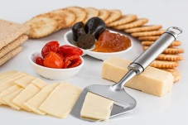
Tuesday Cheese and Crackers

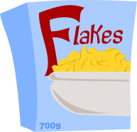
Wednesday Cereal
(Cheerios, Ready Brek, Shreddies, Rice Krispies)
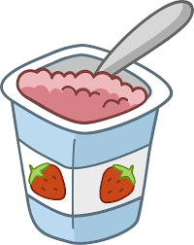
Thursday Yoghurts
Friday Scones
(Classes to take turns when baking)
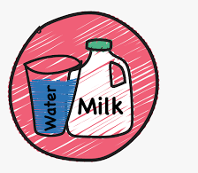
- Semi-skimmed milk and water will be available every day.

- A selection of fresh and tinned fruit and vegetables will be available every day.

- Non-dairy alternatives provided for those children with dietary requirements (Butter, cheese, yoghurts.)

