Getting Ready to Learn
Big Bedtime Read
Friday 24th November 2023
Dear parent/carer,
We hope you will enjoy sharing our Story Bags with your child at home. This is part of our Getting Ready to Learn initiative this month.
Children bring Story Bags home every Monday/Tuesday and return every Friday. Thank you for looking after the books, please check that all books are placed back in the bag before returning to SNS.
This Friday, 24th November, we are having a Big Bedtime Read day in Nursery and we would like the children to come wearing PJs over their school uniform. We will have a special day celebrating how wonderful sharing books together really is, by sharing stories in a cosy environment, just like at bedtime.
We encourage you to spend time reading to or with your child as it really helps support emotional well-being and strengthens bonds.
Sharing a book together:
This Photo by Unknown Author is licensed under CC BY-NC
- helps create a love of reading
- develops language skills
- encourages exploration of life experiences, feelings and ideas
- stimulates imagination
- builds knowledge and skills
Bedtime Routines are so important.
Make sure your child is calm and ready for bed by having regular routines. Too much stimulation just before bed can wake your child up again. It can help to have some ‘winding down’ and doing some calmer activities, like reading.
An example of a routine could be:
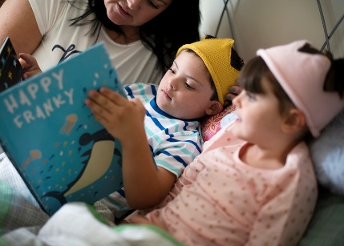
- have a bath, then put on night clothes
- have supper and a milky drink
- brush teeth
- go to bed
- share a bedtime story
- have a goodnight kiss and cuddle
Did you know?
Three to four year olds need about 12 hours of sleep, but the amount can range from 8 hours up to 14!
Research indicates that screen time hampers sleep, so let’s get that bedtime reading routine going.
Best wishes,
The Strathfoyle staff team

