[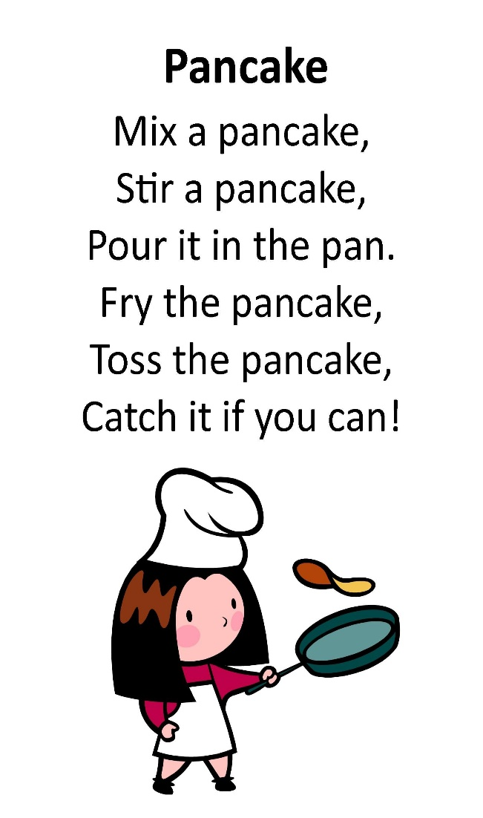](https://www.google.com/url?sa=i&url=https%3A%2F%2Fwww.pinterest.com%2Fpin%2F515028907358386537%2F&psig=AOvVaw2fHLiCR7lNNgudX98n9YYr&ust=1612618135421000&source=images&cd=vfe&ved=0CAIQjRxqFwoTCPDR8-_s0u4CFQAAAAAdAAAAABAJ)

**Rhyme - Down in the Jungle**

Down in the Jungle where nobody goes,

There’s a big elephant washing his clothes.

With a rub-a-dub here and a rub-a-dub there,

That’s the way he washes his clothes

[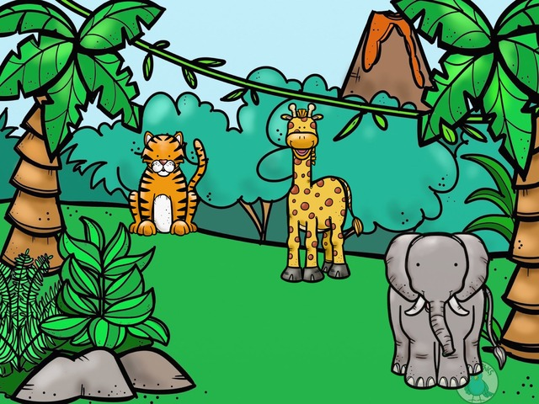](https://www.google.com/url?sa=i&url=https%3A%2F%2Fwww.tinytap.it%2Factivities%2Fg31f4%2Fcommunity%2Fprofile%2Fsj-edwards%2F&psig=AOvVaw0zm_paprh1GsEsnRV6a8xG&ust=1612618802200000&source=images&cd=vfe&ved=0CAIQjRxqFwoTCJDcqK7v0u4CFQAAAAAdAAAAABAD)

**Ask your child:**

Is it a boy elephant or a girl elephant?

Is it a big, small, long, short,… elephant?

Make up other animals/ actions/ change the words in red

Have fun making pancakes, talking about the ingredients, action words and singing the song!

**Hide’n Seek – ‘Where is Teddy?’**

*This is a fun game to support your child’s understanding of prepositional language, such as;* ***in, on, under, in front, behind*** *etc.*

**You will need your favourite teddy**.

* Hid e teddy and ask your child “Where is teddy?”
* Encourage your child to use full sentences E.g.

“Teddy is **on** the shelf”, “Tedding is **in** the box”, “Teddy is **under** the bed”

* To support your child model language – “ I can see the teddy, he is **on** the shelf”
* Take turns let your child hide the teddy - model full sentences to your child using prepositional language.