**SS**

**Parent/Adult – you will need to find socks to play the game.**

* Can you find all the matching socks?
* 2 matching socks are called a pair
* What colours can you see?
* Why do they match?
* Do the socks have a pattern? Stripes, spots , squiggles
* Play a game of ‘Pairs’ – turn all the socks over and take turns finding pairs
* Help mum/dad pair the socks during laundry time
* Using real socks have them all mixed up –who can find the most pairs of socks

***These games/activities will support your child’s development in, turn taking/ attention and listening/ early mathematical understanding/ language/ counting/ colour/ pattern/ memory***

 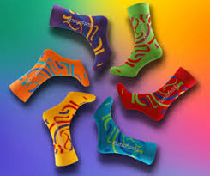 

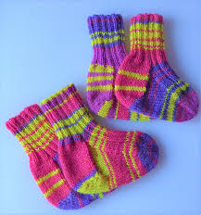



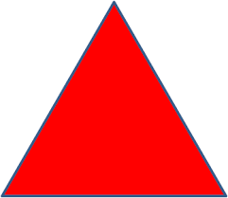



**Pattern and Size Fun**

* Can you collect shoes/clothing of different sizes and talk about them using words like bigger/longer
* Do you see any patterns?
* Go for a walk and collect some sticks. Can you order them by length?
* Which is the longest? Which is the shortest? Can you find something at home the same length as one of the sticks?

**Shape Detectives**

**This game will help me learn all about the square shape.**

* Talk about the square and what it looks like,
* Count the sides; are the sides all the same?
* Sing the square song while tracing your finger around a square

**Now it is time for some detective fun!**

* Play a song and see how many squares your child can find in your house during the song.
* Count them once the song has finished
* To extend you can play this game with different shapes