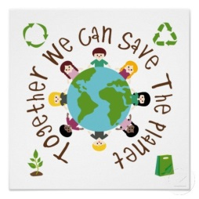
January Eco News

RSPB
The children have been feeding the birds and observing them in the school garden. We are trying hard to identify them. We will soon be making our own bird cakes and feeders to hang in our outdoor areas.

We will be talking part in the RSPB’s ‘Big School’s Bird Watch’ between 6th January- 20 February, we have attached our observation sheet if you would like to participate at home also. Please visit the RSPB website for more activities.

Our Garden
The weather has been a lot colder recently and we have been taking the opportunity to explore and observe the weather outdoors (ice, frost, rain.) We have been talking about the Winter season, how we dress for it and how we stay safe. We have also been continuing to prepare our Garden and going on minibeast hunts.

Recycling
We have been learning about what bin to put our rubbish in- food (small black food bin)/ paper and plastic (blue bin) and other waste (black bin.) Please encourage your children to participate at home also.

Thank you for bringing in some Junk for us to make models with- we really appreciate it.

We will be having a visit from Peter McErlean from Keep Northern Ireland Beautiful to tell us about the ‘Wheelie Big Challenge.’

Eco Jobs
This term, we will continue to develop our Eco awareness and when it is their turn to be Teacher Helper, each child will have an opportunity to take on the role of ‘Eco Buddy.’ They have already been busy:
- Picking up litter
- Weeding and preparing the planting boxes
- Using our own compost to fertilise the soil
- Planting alliums (they will attract insects)
- Pruning, weeding and removing old lavender from the Sensory bed.
- Harvesting kale and parsley which was given to a local food bank.

Keep an eye on our new School website for updates about all things ECO and photos of the children in action.

Please continue to talk to your child about our ECO Code and how we can POP!

Are you ready to POP?
Protect Our Planet

